Deep Dive : A System Resource Monitor

Operating Systems (IT253) Course Project

### Submitted in partial fulfillment of the requirements for the degree of

### BACHELOR OF TECHNOLOGY

### In

### INFORMATION TECHNOLOGY

### by

### NITHIN S 221IT085

AYUSH KUMAR 221IT015

JAY CHAVAN 221IT020



### DEPARTMENT OF INFORMATION TECHNOLOGY NATIONAL INSTITUTE OF TECHNOLOGY KARNATAKA SURATHKAL, MANGALORE -575025

### March, 2024

**D E C L A R A T I O N**

We hereby *declare* that the *OS Project Report* entitled **“Deep Dive : A System Resource Monitor”** which is being submitted to the National Institute of Technology Karnataka Surathkal, in partial fulfillment of the requirements for the award of the Degree of Bachelor of Technology in the Department of Information Technology, is a ***bonafide report of the work carried out by us.*** The material contained in this project report has not been submitted to any University or Institution for the award of any degree.

Nithin S Ayush Kumar Jay Chavan

Signature Signature Signature

Department of IT Department of IT Department of IT

Place : NITK, SURATHKAL

Date : 25 March 2024

**CERTIFICATE**

This is to certify that the Seminar entitled **“Deep Dive : A System Resource Monitor”** has been presented by Nithin S (221IT085), Ayush Kumar (221IT015) & Jay Chavan ( 221IT020), students of IV semester B.Tech.(I.T), Department of Information Technology, National Institute of Technology Karnataka, Surathkal, on 25 March, 2024, during the even semester of the academic year 2023 - 2024, in partial fulfillment of the requirements for the award of the degree of Bachelor of Technology in Information Technology.

Examiner-1 Name Examiner-2 Name

Signature of the Examiner-1 with Date Signature of the Examiner-2 with Date

Place: Date:

**ABSTRACT**

This report presents Deep Dive, a System Resource Monitor which is a sophisticated software project aimed at providing users with an intuitive and comprehensive tool for monitoring system resources in real-time. Leveraging the power of Python and Qt GUI interface, this project offers a user-friendly experience while ensuring accurate tracking and analysis of critical system metrics. The system resource monitor provides insights into CPU usage, memory consumption, disk activity, network traffic, and other vital parameters, enabling users to identify performance bottlenecks, optimize resource utilization, and troubleshoot potential issues efficiently. With its responsive and visually appealing interface, Deep Dive empowers both novice and advanced users to make informed decisions about system resource management, thereby enhancing system stability, reliability, and overall performance.

**TABLE OF CONTENTS**

**CHAPTER 1: INTRODUCTION 1**

**CHAPTER 2: OBJECTIVE** **2**

**CHAPTER 3: METHODOLOGY** **3**

Code Structure3

**CHAPTER 4: SYSTEM DESIGN 5**

Block Diagram5

**CHAPTER 5: IMPLEMENTATION****6**

**CHAPTER 6: CONCLUSION 12**

Result 12

Future Scope 17

References 18

**LIST OF FIGURES**

#### Figure 3.1: Terminal Activity of the application 4

#### Figure 4.1: Flowchart of Application Architecture 5

#### Figure 6.1: Resources Tab Screen 12

#### Figure 6.2: Activities Tab Screen 13

#### Figure 6.3: Process Minitab Screen 13

#### Figure 6.4: Performance Tab Screen 14

#### Figure 6.5: Connections Tab Screen 15

#### Figure 6.6: Information Tab Screen 16

#### Figure 6.7: About Tab Screen 16

**LIST OF TABLES**

#### Table 5.1: Origin of Statistics 6

# CHAPTER 1: INTRODUCTION

In the dynamic realm of modern computing, the efficient management of system resources emerges as a critical necessity, underpinning the smooth operation and longevity of computing environments across diverse domains. As the complexity of software applications escalates and the demands on hardware intensify, the need for sophisticated tools that facilitate real-time monitoring and analysis of system resources becomes increasingly pronounced. It is within this context that our project, "Deep Dive: A System Resource Monitor," assumes significance. Deep Dive represents a concerted effort to address the multifaceted challenges associated with system resource management by providing users with a comprehensive and intuitive platform for monitoring and analyzing crucial system metrics. By harnessing the capabilities of Python for robust backend functionality and Qt GUI interface for seamless user interaction, Deep Dive endeavors to redefine the paradigm of system resource monitoring, offering users unprecedented insights into CPU usage, memory consumption, disk activity, network traffic, and other key performance indicators.

**Language Used :** Python

**Libraries Used** : Psutil, Os, PyQt5, PyCPUInfo, Distro, Numpy

**Working Environment** : Any Linux Distro

**Requirements** : A Linux Environment, Numpy, Psutil, Distro, PyQT5, PyQtGraph, PyCPUinfo,

PyQTChart

# CHAPTER 2: OBJECTIVE

## 

At the core of Deep Dive lies a steadfast commitment to empowering users with the tools and insights necessary to optimize system resources effectively. Our project sets out with a singular objective: to equip users with the means to not merely monitor but also proactively manage system resources in real-time. Through the provision of actionable insights into critical performance metrics, Deep Dive enables users to identify bottlenecks, fine-tune resource allocation, and swiftly address any arising performance issues. By fostering a deeper understanding of system resource utilization patterns and trends, the tool aims to enhance system efficiency, reliability, and overall performance. Through its intuitive interface and advanced visualization techniques, Deep Dive seeks to democratize system resource management, making it accessible and comprehensible to users across diverse technical backgrounds and proficiency levels.

The objective is to explore all these fields:

* + **CPU:** Percentage, Clock Speeds, Occupancy, Duration, Counts of Context Switches, System calls and hardware interrupts
  + **Memory:** Utilization, Swapping rate, Occupancy, Physical and logical partition.
  + **Internet:** Packet Count, Size, Rate, Transfer rate, Transmission, Dropped transfers.
  + **Processes:** PIDs, names, terminal, usernames, states, CPU/Memory Usage, context switches, threads, Kill, resume, Terminate, Suspend Options.
  + **System/Hardware:** OS, Kernel names, Versions, CPU name, Vendor, Frequency, Features.
  + Visually represent real time data changes for clear understanding

The main goal is to integrate all these metrics into one application and give a naive user all the in depth details about his/her system, which is not done by conventional system monitors.

# CHAPTER 3: METHODOLOGY

The development of Deep Dive is underpinned by a meticulously crafted methodology that combines rigorous data collection, sophisticated analysis, and intuitive presentation of insights. Leveraging Python's versatility and robustness, the tool employs a multifaceted approach to gather, process, and analyze data pertaining to various system metrics, including CPU usage, memory utilization, disk activity, network statistics, and process details. Through the adept utilization of algorithms and techniques, Deep Dive ensures the accuracy, responsiveness, and reliability of resource monitoring, even in the face of dynamic and rapidly changing computing environments. Real-time visualization of this data constitutes a cornerstone of the tool, facilitating instantaneous insights into system performance and enabling users to make informed decisions regarding resource management. By adhering to a structured methodology that prioritizes user-centric design principles and robust backend functionality, Deep Dive endeavors to deliver a seamless and immersive experience that empowers users to unlock the full potential of their computing environments.

## Code Structure

1. **commons:** Consist for python code for the frontend of the application. Its designed using Qt5 Designer
2. **readers:** 
   * **mainwind** : Stands for the main window. The data for all 6 tabs are collected here.
   * **procwind** : Stands for the process window. It provides user interaction for process control.
3. **screens:** 
   * **mainwind** : Consists of interface design for all the tabs.
   * **procwind** : Consists of interface design for the mini process tabs.
4. **widgets** :
   * **lgptwdgt, ntwkwdgt, perfwdgt, phptwdgt** : All these are used to design widgets for tabs

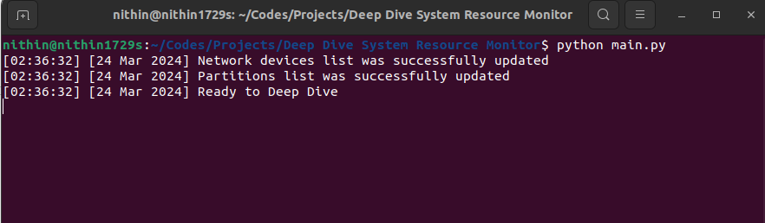

*Figure 3.1: Terminal Activity of the application*

Deep Dive employs a variety of techniques for data collection to ensure comprehensive coverage of system metrics. This includes interfacing with operating system APIs to retrieve real-time data on CPU usage, memory utilization, disk activity, network statistics, and process details. Additionally, the tool may utilize performance monitoring tools or libraries to access low-level system information with precision and accuracy.

Deep Dive prioritizes real-time visualization as a key component of its user interface. Utilizing modern visualization libraries and techniques, the tool presents system metrics in a visually appealing and intuitive manner. This allows users to quickly grasp the current state of their system's performance and identify any areas requiring attention. Interactive elements may be incorporated to enable users to drill down into specific metrics or timeframes for deeper analysis. Deep Dive is designed to adapt seamlessly to dynamic and rapidly changing computing environments. This adaptability is achieved through robust error handling, graceful degradation, and automatic recovery mechanisms to maintain uninterrupted monitoring even in the face of transient errors or system fluctuations.

**CHAPTER 4: SYSTEM DESIGN**

## Block Diagram

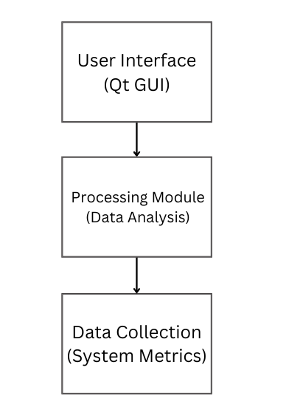

*Figure 4.1: Flowchart of Application Architecture*

The Data Collection is done by Python libraries like Psutil, PyCPUInfo, Distro and os. These raw system metrics are analyzed to prepare meaningful statistics in the processing module. More information regarding this is given in the next chapter.

These processed stats are displayed in a user-friendly manner by the PyQt interface.

**CHAPTER 5: IMPLEMENTATION**

In this chapter, we will discuss how the various statistics are collected by our System Resource Monitor using Python Libraries.

| **Description** | **Command Used** |
| --- | --- |
| Name of the Linux Distro | Distro.name() |
| Version of the Linux Distro | distro.version() |
| Hostname of the system | uname().nodename |
| Release of the OS | uname().version |
| Version information of the operating system | uname().version |
| Boot time of the system | psutil.boot_time() |
| Bytes received | nxntiocf.bytes_recv - pvntiocf.bytes_recv |
| Bytes sent | nxntiocf.bytes_sent - pvntiocf.bytes_sent |
| Packets received | nxntiocf.packets_recv - pvntiocf.packets_recv |
| Packets sent | nxntiocf.packets_sent - pvntiocf.packets_sent |
| Bytes received per network interface | nxntioct[indx].bytes_recv - pvntioct[indx].bytes_recv |
| Bytes sent per network interface | nxntioct[indx].bytes_sent - pvntioct[indx].bytes_sent |
| Packets received per network interface | nxntioct[indx].packets_recv - pvntioct[indx].packets_recv |
| Packets sent per network interface | nxntioct[indx].packets_sent - pvntioct[indx].packets_sent |
| Total bytes received | netiocnf.bytes_recv |
| Total bytes sent | netiocnf.bytes_sent |
| Total packets received | netiocnf.packets_recv |
| Total packets sent | netiocnf.packets_sent |
| Receive errors | netiocnf.errin |
| Send errors | netiocnf.errout |
| Dropped packets on receive | netiocnf.dropin |
| Dropped packets on send | netiocnf.dropout |
| Disk read count | diskioqt.read_count |
| Disk write count | diskioqt.write_count |
| Bytes read from disk | mmrysize.format(diskioqt.read_bytes) |
| Bytes written to disk | mmrysize.format(diskioqt.write_bytes) |
| Time spent reading from disk | timevalu.format(diskioqt.read_time) |
| Time spent writing to disk | timevalu.format(diskioqt.write_time) |
| Merged reads | diskioqt.read_merged_count |
| Merged writes | diskioqt.write_merged_count |
| Number of disk partitions | len(partlist) |
| Logical partition device | indx.device |
| Logical partition usage | { "free": mmrysize.format(partfree), "used": mmrysize.format(partused), "comp": mmrysize.format(partcomp), "perc": partperc } |
| Logical partition filesystem information | { "mtpt": indx.mountpoint, "fsys": indx.fstype } |
| Physical partition device | indx.device |
| Physical partition usage | { "free": mmrysize.format(partfree), "used": mmrysize.format(partused), "comp": mmrysize.format(partcomp), "perc": partperc } |
| Physical partition filesystem information | { "mtpt": indx.mountpoint, "fsys": indx.fstype } |
| CPU utilization percentage | int(cpudperc[indx]) |
| Maximum CPU frequency | freqvalu.format(cpudfreq[indx].max) |
| Minimum CPU frequency | freqvalu.format(cpudfreq[indx].min) |
| Current CPU frequency | freqvalu.format(cpudfreq[indx].current) |
| Time spent in user mode | timevalu.format(cputsecs[indx].user) |
| Time spent in user mode with low priority | timevalu.format(cputsecs[indx].nice) |
| Time spent in kernel mode | timevalu.format(cputsecs[indx].system) |
| Time spent idle | timevalu.format(cputsecs[indx].idle) |
| Time spent in I/O wait | timevalu.format(cputsecs[indx].iowait) |
| Time spent handling hardware interrupts | timevalu.format(cputsecs[indx].irq) |
| Time spent handling software interrupts | timevalu.format(cputsecs[indx].softirq) |
| Time spent by other operating systems running in a virtualized environment | timevalu.format(cputsecs[indx].steal) |
| Time spent running a guest operating system | timevalu.format(cputsecs[indx].guest) |
| Time spent running a niced guest | timevalu.format(cputsecs[indx].guest_nice) |
| User CPU time percentage | cputperc[indx].user |
| User CPU time percentage with low priority | cputperc[indx].nice |
| System CPU time percentage | cputperc[indx].system |
| Idle CPU time percentage | cputperc[indx].idle |
| I/O wait CPU time percentage | cputperc[indx].iowait |
| Hardware interrupt CPU time percentage | cputperc[indx].irq |
| Software interrupt CPU time percentage | cputperc[indx].softirq |
| Steal CPU time percentage | cputperc[indx].steal |
| Guest CPU time percentage | cputperc[indx].guest |
| Niced guest CPU time percentage | cputperc[indx].guest_nice |
| CPU name | get_cpu_info().get("brand_raw") |
| CPU vendor ID | get_cpu_info().get("vendor_id_raw") |
| CPU frequency | get_cpu_info().get("hz_advertised_friendly") |
| Number of CPU cores | get_cpu_info().get("count") |
| CPU architecture (32-bit/64-bit) | get_cpu_info().get("bits") |
| CPU architecture | get_cpu_info().get("arch") |
| CPU stepping | get_cpu_info().get("stepping") |
| CPU model | get_cpu_info().get("model") |
| CPU family | get_cpu_info().get("family") |
| CPU feature flags | get_cpu_info().get("flags") |
| Process ID | str(proc.info["pid"]) |
| Process name | str(proc.info["name"]) |
| Terminal associated with the process | str(proc.info["terminal"]) |
| User running the process | str(proc.info["username"]) |
| Process status (running, sleeping, etc.) | str(proc.info["status"]) |
| CPU usage percentage by the process | %2.1f" % proc.info["cpu_percent"] |
| Memory usage percentage by the process | "%2.1f" % proc.info["memory_percent"] |
| Number of threads created by the process | str(proc.info["num_threads"]) |
| Username of the current user | getpass.getuser() |
| CPU usage percentage | psutil.cpu_percent() |
| Memory usage percentage | psutil.virtual_memory().percent |
| Swap memory usage percentage | psutil.swap_memory().percent |
| Disk usage percentage of the root directory | psutil.disk_usage("/").percent |
| Percentage of used memory | psutil.virtual_memory().used * 100 / psutil.virtual_memory().total |
| Percentage of cached memory | psutil.virtual_memory().cached * 100 / psutil.virtual_memory().total |
| Percentage of free memory | psutil.virtual_memory().free * 100 / psutil.virtual_memory().total |
| Absolute value of used memory | mmrysize.format(psutil.virtual_memory().used) |
| Absolute value of cached memory | mmrysize.format(psutil.virtual_memory().cache) |
| Absolute value of free memory | mmrysize.format(psutil.virtual_memory().free) |
| Absolute value of total memory | mmrysize.format(psutil.virtual_memory().total) |
| Absolute value of active memory | mmrysize.format(psutil.virtual_memory().active) |
| Absolute value of memory buffers | mmrysize.format(psutil.virtual_memory().buffers) |
| Absolute value of shared memory | mmrysize.format(psutil.virtual_memory().shared) |
| Absolute value of slab memory | mmrysize.format(psutil.virtual_memory().slab) |
| Percentage of used swap memory | (psutil.swap_memory().used * 100 / psutil.swap_memory().total) if psutil.swap_memory().total > 0 else 0 |
| Percentage of free swap memory | (psutil.swap_memory().free * 100 / psutil.swap_memory().total) if psutil.swap_memory().total > 0 else 100 |
| Absolute value of used swap memory | mmrysize.format(psutil.swap_memory().used) |
| Absolute value of free swap memory | mmrysize.format(psutil.swap_memory().free) |
| Absolute value of total swap memory | mmrysize.format(psutil.swap_memory().total) |
| Absolute value of swap memory in | mmrysize.format(psutil.swap_memory().sin) |
| Absolute value of swap memory out | mmrysize.format(psutil.swap_memory().sout) |
| Percentage of CPU usage | psutil.cpu_percent() |
| Percentage of free CPU usage | 100 - psutil.cpu_percent() |
| Number of context switches since boot | psutil.cpu_stats().ctx_switches |
| Number of interrupts serviced since boot | psutil.cpu_stats().interrupts |
| Number of software interrupts since boot | psutil.cpu_stats().soft_interrupts |
| Number of system calls since boot | psutil.cpu_stats().syscalls |
| Process name | procobjc.name() |
| CPU usage percentage by the process | procobjc.cpu_percent() |
| Memory usage percentage by the process | procobjc.memory_percent() |
| CPU number where the process is running | procobjc.cpu_num() |
| Number of threads created by the process | procobjc.num_threads() |
| User running the process | procobjc.username() |
| Terminal associated with the process | procobjc.terminal() |
| Niceness value of the process | procobjc.nice() |
| I/O scheduling class of the process | procobjc.ionice().value |
| Number of context switches experienced by the process | procobjc.num_ctx_switches().voluntary, procobjc.num_ctx_switches().involuntary |
| Parent process ID | procobjc.ppid() |
| Process status (running, sleeping, etc.) | procobjc.status().title( |
| Time when the process was created | procobjc.create_time() |
| Time when the statistics were acquired | time.time() |

*Table 5.1: Origin of Statistics*

Many more metrics are displayed in the application which has a similar origin. Since a lot of function calls are done repeatedly to acquire these metrics the application gets overhead and a high startup time.

This might be improved by implementing multithreading and also making some changes in the architecture of our application, which is a future scope.

These docs below are referred extensively to prepare the resource monitor application.

PSutil : <https://psutil.readthedocs.io/en/latest/>

PyCPUInfo : <https://github.com/workhorsy/py-cpuinfo>

os: <https://docs.python.org/3/library/os.html>

Distro : <https://distro.readthedocs.io/en/latest/>

**CHAPTER 6: CONCLUSION**

## RESULTS

**Resource Tabscreen :**

* Displays CPU, Memory, and Swap Memory usage using a radial pie chart.
* Bottom status bar shows CPU Percentage, Memory Percentage, Swap Percentage, and Disk Percentage, along with Linux Kernel Version and owner’s name.
* [The number of system calls is always set to 0 in Linux.](https://psutil.readthedocs.io/en/latest/#:~:text=syscalls%3A%20number%20of%20system%20calls%20since%20boot.%20Always%20set%20to%200%20on%20Linux.)

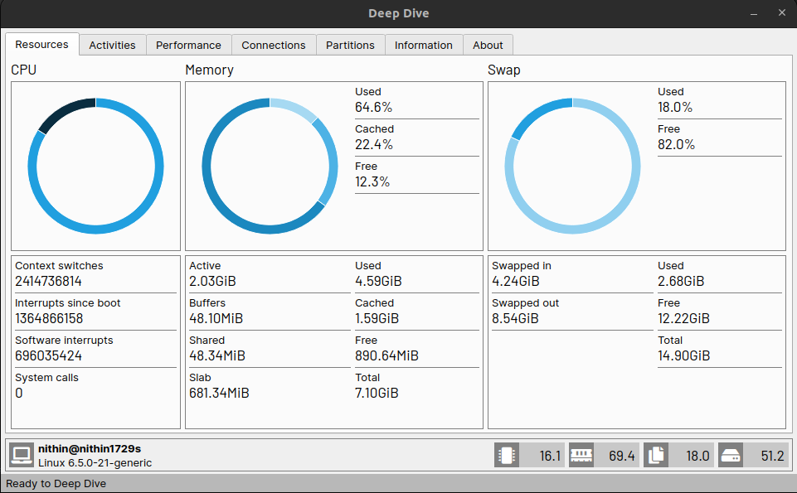

*Figure 6.1: Resources Tab Screen*

**Activities Tabscreen :**

* Lists processes currently running on the local machine.
* Provides control over terminating, suspending, resuming processes.
* Shows details about the user who created the process, Process ID, Process’s Parent ID, CPU % used by the process, etc.

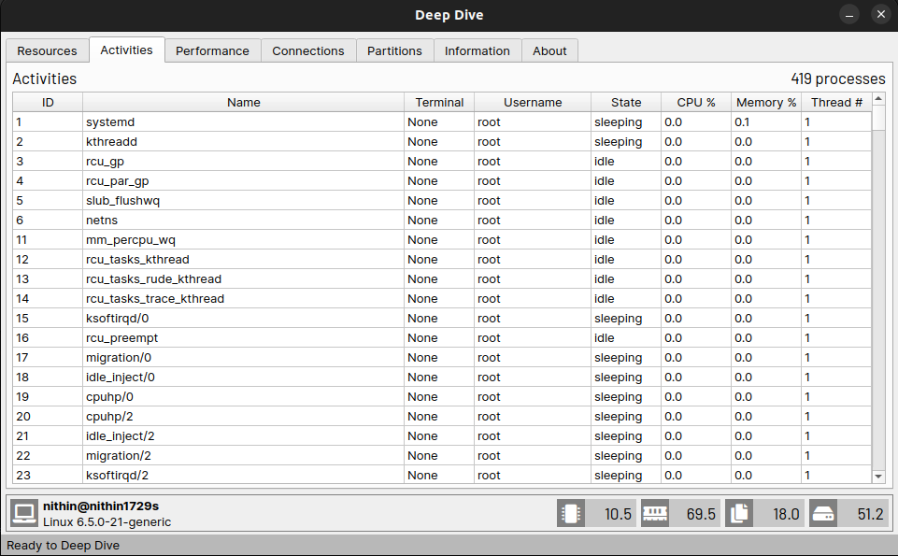

*Figure 6.2: Activities Tab Screen*

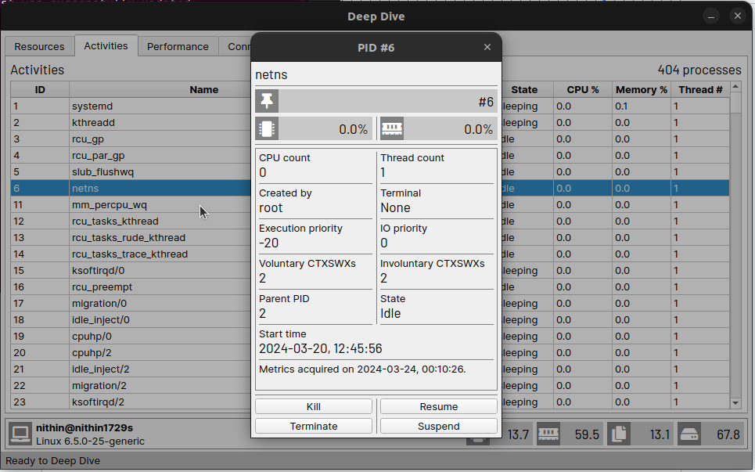

*Figure 6.3: Process Mini tab Screen*

**Performance Tabscreen :**

* Provides information regarding various statistics for each core of the processor.
* Displays CPU Name, Vendor, Count, Architecture, Feature flags, etc.
* Feature flags represent specific capabilities or features supported by the CPU.

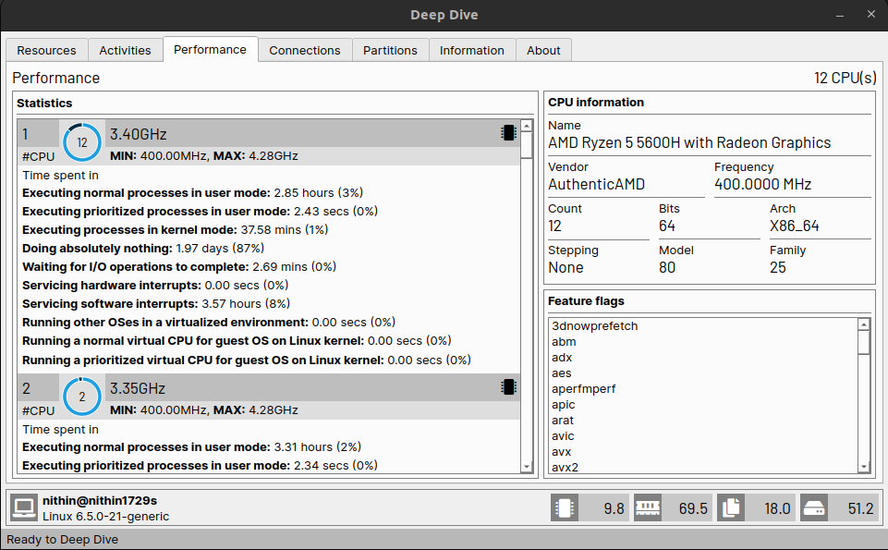

*Figure 6.4: Performance Tab Screen*

Feature flags, also known as CPU flags or CPU feature flags, are indicators that represent specific capabilities or features supported by a CPU (Central Processing Unit). These flags are used by operating systems, software, and sometimes even by other hardware components to determine the available features and optimize performance accordingly.

**Connection Tab Screen :**

* Displays statistics about internet speed and keeps track of the number of bytes or packets received, and data uploaded or downloaded.
* Includes information about all Network Interface Cards (NIC) present in the system.
* Provides a refresh button to update and view new internet connections.

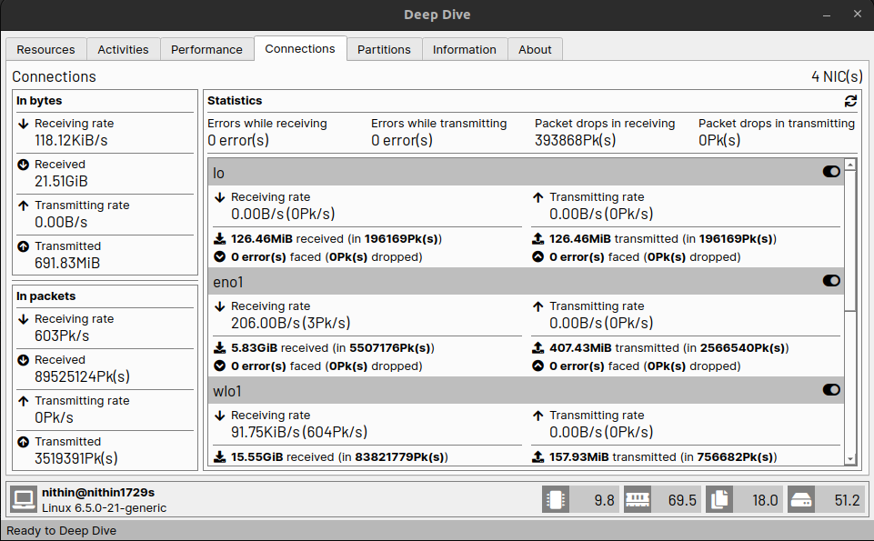

*Figure 6.4: Connections Tab Screen*

**Partition Tabscreen :** Shows details about the physical and logical partition in the hard disk. It also includes no of read count, write count, merged writes etc

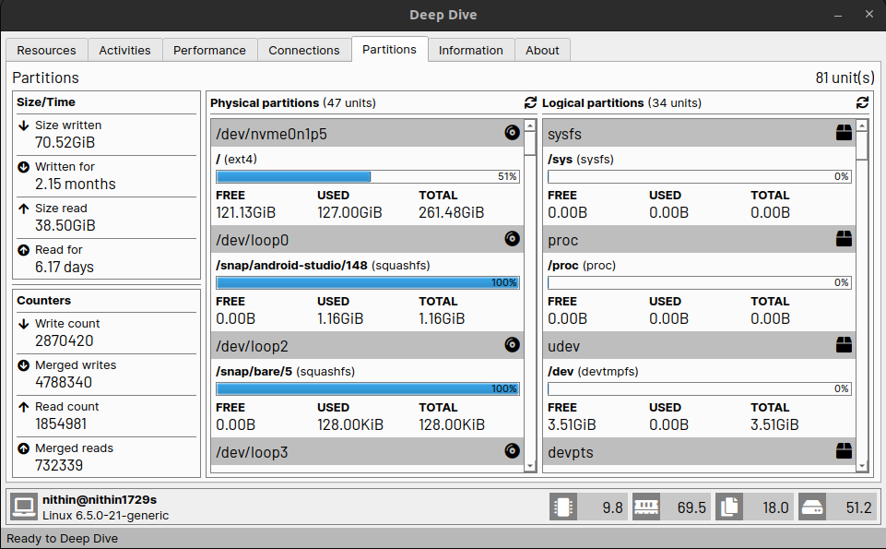

*Figure 6.5 : Partitions Tab Screen*

**Information & About Tabscreen :** Gives information regarding the linux distro and the version of dependencies.

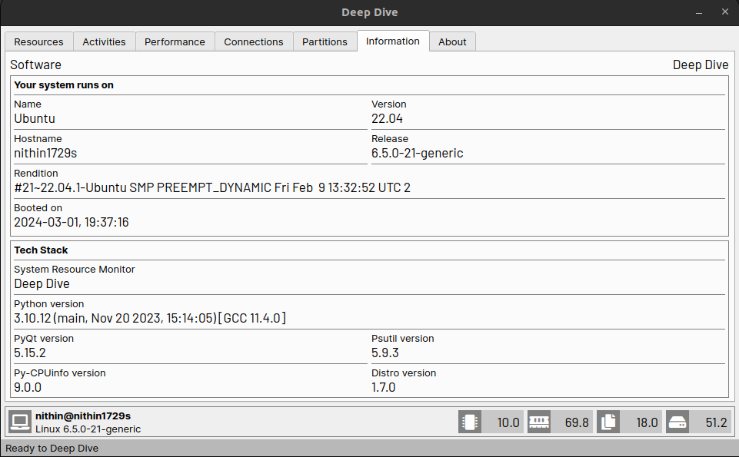 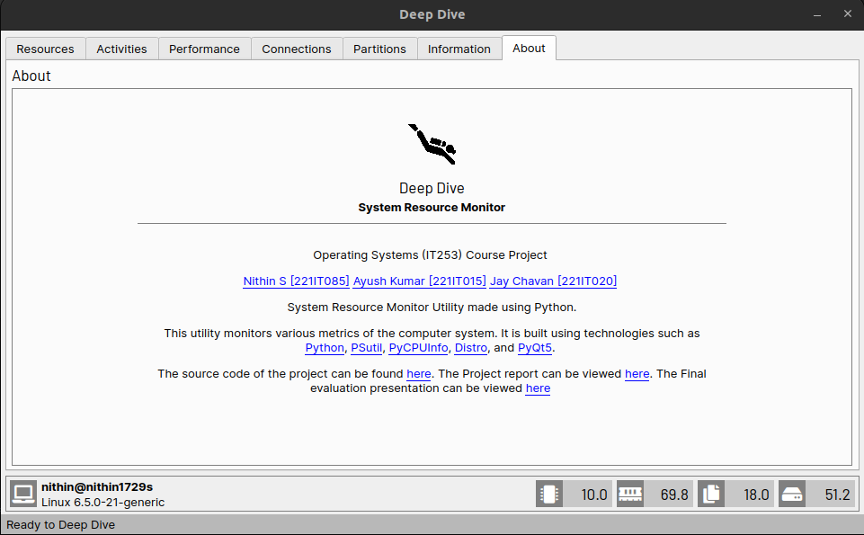

*Figure 6.6 : Information Tab Screen Figure 6.7: About Tab Screen*

## FUTURE WORK

**Reduce StartUp Time**: Come up with a new architecture which reduces the number of function calls

to reduce the start up time of the application. The goal would also be to decrease the overhead of the application.

**Enhanced Data Analysis**: Introduce advanced statistical analysis and machine learning algorithms to provide deeper insights into system resource usage patterns, enabling predictive analysis for proactive resource management and optimization.

**Multi-Platform Support:** Extend compatibility to various operating systems beyond the current scope, such as macOS and Linux distributions, to cater to a broader user base and enhance the tool's versatility.

**Customization Options**: Implement features that allow users to customize the dashboard layout, color schemes, and visualization preferences according to their specific requirements and preferences.

**Alerting Mechanisms**: Incorporate real-time alerting mechanisms to notify users about critical system resource thresholds being exceeded, enabling timely intervention to prevent performance degradation or system failures.

**Historical Data Analysis**: Develop functionality to store and analyze historical system resource usage data, facilitating trend analysis, capacity planning, and long-term performance monitoring.

**Remote Monitoring and Management:** Introduce capabilities for remote monitoring and management, allowing users to monitor system resources across multiple machines from a centralized dashboard and perform management tasks remotely.

**Integration with Cloud Platforms**: Integrate with popular cloud platforms such as AWS, Azure, and Google Cloud to provide seamless monitoring and management of cloud-based resources, enabling hybrid and multi-cloud environments.

**Security and Compliance Features**: Enhance the tool's security features to ensure compliance with industry standards and regulations, such as GDPR and HIPAA, by implementing encryption, access controls, and audit trails for sensitive system resource data.

**Resource Allocation Optimization:** Develop algorithms and tools to dynamically adjust resource allocation based on workload demands and performance metrics, optimizing resource utilization and enhancing overall system efficiency.

## 

## REFERENCES

G. Juve et al., "Practical Resource Monitoring for Robust High Throughput Computing," 2015 IEEE International Conference on Cluster Computing, Chicago, IL, USA, 2015, pp. 650-657, doi: 10.1109/CLUSTER.2015.115.

M. Andreolini, M. Colajanni, M. Pietri and S. Tosi, "Real-time adaptive algorithm for resource monitoring," Proceedings of the 9th International Conference on Network and Service Management (CNSM 2013), Zurich, Switzerland, 2013, pp. 67-74, doi: 10.1109/CNSM.2013.6727811